ACKNOWLEDGEMENTS
I will like to thank the director of COLTECH Prof Tsi Evaristus Angwafo, the Head of Department of Computer Engineering COLTECH Dr Forbacha as well as our lecturers.
I am very thankful to my supervisors Engr Achegnui Juven, Engr Ghany Elisha, Mme Divina Mbel and all the other supervisors at Traitz Tech for their invaluable guidance and advice during my internship.
I am thankful to myself for my perseverance and steadfastness during this period at Traitz Tech.
I also thank the teams I worked with and all the other interns for their support and collaboration.
Overall, my parents made my stay at stay-at-home-work an enjoyable one and I am grateful to them for making it so.

DEDICATION
I will like to dedicate this project to the Traitz Tech family, my parents and close friends who supported me with their countless sacrifices throughout my internship period.

TABLE OF CONTENT

FOREWORD
My four weeks Internship program work term was with Traitz Tech Bambili. I was involved in the area of data science and machine learning during my work term, all of which will be outlined in this report. This report will cover some background information on the project I was involved in
The task I was given at Traitz Tech was to;
- Learning python and having a good knowledge on how to use it and put it in practice
- Analyze and understanding datasets given to me
- Cleaning and visualization of the datasets
- Presentation of analysis, findings and key insights and being able to use it to answer real life questions
During my internship I also learned about;
- Git hub and git commands and storing my projects on git hub.
- Python programming language
I acquired many new technical skills throughout my work term. I acquired new knowledge in the area of data science and machine learning. Then I got introduced to the area of team collaboration and how to approach it. Most importantly, the work experience was very good which included good fellowship, cooperative teamwork and accepting responsibilities. This report concludes with my overall impressions of my work experience as well as my opinion of the Industrial Internship Program in general.

LIST OF FIGURES, MAPS AND PHOTOGRAPHS

CHAPTER 1
GENERAL INTRODUCTION
1. Generalities of the location
1.1 Relief and soil
The topography in this area is flat plain soil found here are clay, which are usually dark loam in plain areas and sandy soils
1.2 Climate
In bambilli the climate is classified as a tropical highland climate. The average temperature range 18˚C to 25˚C with heavy rainfall during the rainy season
1.3 Vegetation
The climate of bambilli is like that of most parts of the Northwest Region is generally cool and pleasant. There are two main seasons the rainy season that lasts for about six months with an annual rainfall of about 200mm. The other half of the year is the dry season. The vegetation is mainly savannah
DESCRIPTION OF THE HOST INSTITUTION

Traitz Tech - Company Overview

1. Company History
Founded on July 1, 2023, Traitz Tech is a forward-thinking startup, created by three co-founders: Engr Fonguong Edrick (CEO), Engr Foryoung Junior (CTO), and Engr Achegnui Juven (CMO). The company’s name symbolizes the unity and collaboration among its founders, combining their unique skills to provide innovative technological solutions.
Established during a pivotal meeting in Bambili, Traitz Tech is headquartered in the Northwest Region of Cameroon, opposite the University of Bamenda. This location allows the company to stay connected to the local tech ecosystem while contributing to regional development.

2. Vision and Mission

Vision
Traitz Tech envisions a digitally empowered Cameroon, where accessible and innovative technological solutions foster development, connectivity, and inclusive growth. The company aims to bridge the digital divide and empower businesses and communities with user-friendly solutions.

Mission
Our mission is to create transformative software solutions that simplify life, connect communities, and drive sustainable growth. We focus on delivering user-friendly platforms that solve real-world problems and contribute to long-term societal and economic well-being. This is supported by our dedication to environmentally conscious practices and community development.

3. Key Services

3.1. Software Development
Traitz Tech specializes in building robust and scalable software that meets the needs of busineses and users alike. Our focus is on creating high-performance mobile and web applications that streamline operations, enhance user experiences, and are backed by the latest technology stacks.

3.2. Cloud Computing
We provide cloud computing solutions that offer flexibility, scalability, and security to businesses. By leveraging platforms like AWS, Google Cloud, and Azure, we ensure that our clients’ operations run smoothly and efficiently, with optimized cloud infrastructure.

3.3. AI and Machine Learning
Traitz Tech develops AI and Machine Learning solutions that enable businesses to automate processes, make data-driven decisions, and deliver personalized user experiences. From predictive analytics to chat bots, we offer tailored AI/ML solutions to meet diverse business needs.

3.4. Business Consultation and Branding
We help companies define their identity and navigate digital transformation through business consultation and branding services. Whether you're a start-up establishing your brand or an established company looking for fresh perspectives, we offer insights that drive growth and success.

3.5. Community Development
Traitz Tech is dedicated to using technology to address social issues and empower communities. Our community development initiatives focus on increasing digital literacy, improving access to resources, and promoting technology inclusion, particularly in underserved areas.

4. Company Structure
Traitz Tech’s leadership team is committed to innovation, collaboration, and excellence in delivering world-class technology solutions. Key members include:
- Engr Fonguong Edrick - Chief Executive Officer (CEO)
- Engr Foryoung Junior - Chief Technology Officer (CTO)
- Engr Achegnui Juven - Chief Marketing Officer (CMO)
- Engr Ghany Elisha - Chief Operating Officer (COO)
- Engr Yengong Milton - Backend Lead
- Engr Nkimih Albert - Frontend Lead

5. Logo and Brand Identity

The Traitz Tech logo reflects the core values of innovation, community, and problem-solving. It combines symbols of collaboration and coding:
- Forward slash (/) and backslash (): These represent the merging of ideas and the collaborative nature of our solutions.
- Curly braces ({ }): These symbolize the building blocks of technology, representing our focus on constructing solutions that address real-world needs.
- Color scheme:
  - Blue: Represents trust and our commitment to addressing the community’s needs.
  - Purple: Symbolizes creativity, innovation, and the tools we use to build impactful solutions.

6. Achievements and Future Goals

Achievements:
- Award-Winning Projects: Traitz Tech has won several prestigious awards for its innovative software solutions and contributions to the tech industry.
- Client Satisfaction: We pride ourselves on consistently delivering projects that meet and exceed our clients' expectations.
- Completed Software Projects: The company has successfully delivered numerous software development projects, ranging from AI-powered platforms to cloud-based applications.

Future Goals:
- Expansion Across Africa: Traitz Tech aims to broaden its reach, providing services to more countries across Africa and positioning itself as a key player in the continent’s digital transformation.
- AI and ML Growth: We will continue to expand our expertise in AI and Machine Learning, developing advanced solutions to help businesses automate and scale.


- Community Empowerment: Traitz Tech is committed to enhancing its community development efforts, bridging the digital divide, and fostering innovation in underserved regions.

CHAPTER TWO

BEGINNING OF INTERNSHIP
On the 15thof February 2025 was the day I started my internship alongside other interns and we were welcomed by the Traitz Tech team who gave us a short orientation on our duty as interns and also talked us through the different carrier path in the IT field. We were then walked through the various activities and courses we were to do during the internship at Traitz Tech. they later gave us a brief history of the company and the various departments that make up the company and then concluded the presentation with the rules and regulations of the interns and the do’s and don’ts we need to follow while interning at Traitz Tech

Particular | Time
Start date | Feb 15th 2025
End date | March 15th 2025
Total | 1 month
Office hours | 8am – 3pm
Working hours | 6 hours
Working days | Tuesday to Saturday
Table 1: Internship Duration Schedule

WEEKLY REPORT

Week one (15th - 22nd February 2025)
During my first week, I downloaded Visual Studio Code as well as python and jupyter extensions into the Visual Studio Code. We (the interns) were introduced into python, started learning about Lists (summing, appending, replacing and deleting from a list), Tuples (converting tuples into list and vice versa as well as how to append and delete from a tuple), dictionaries and loops as well as exercises on jupyter and tutorial videos on python

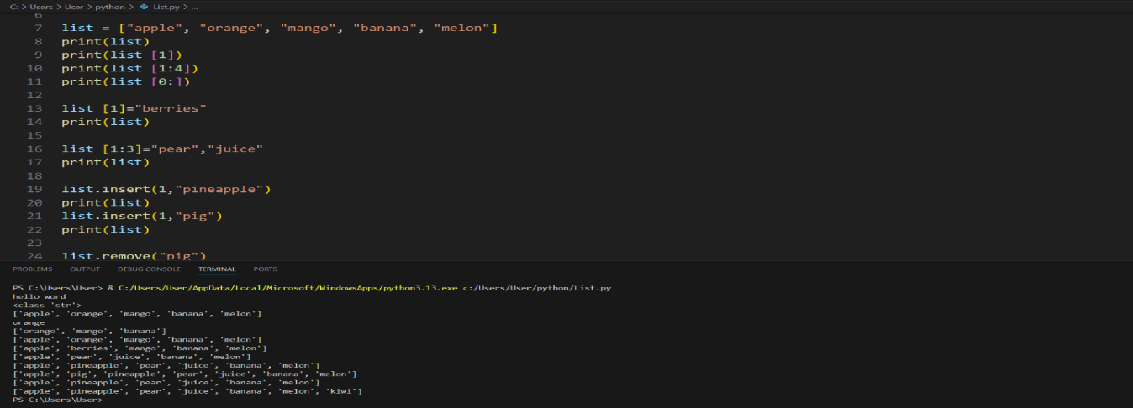

Figure 1: List
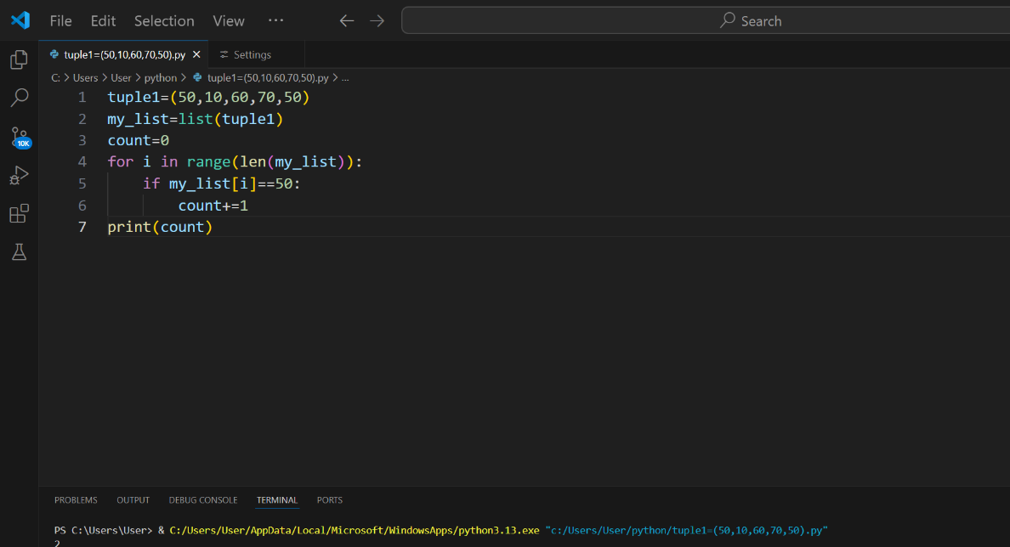

Figure 2: Tuple
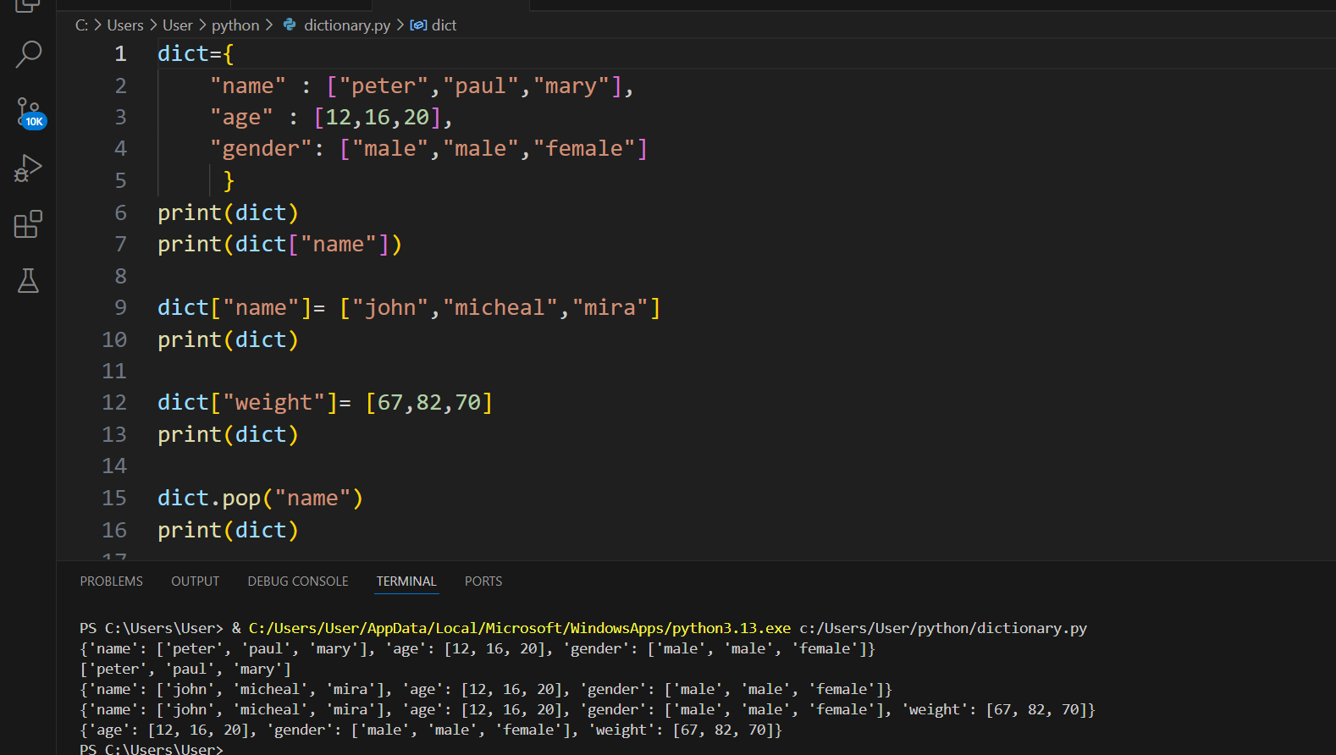

Figure 3: Dictionary
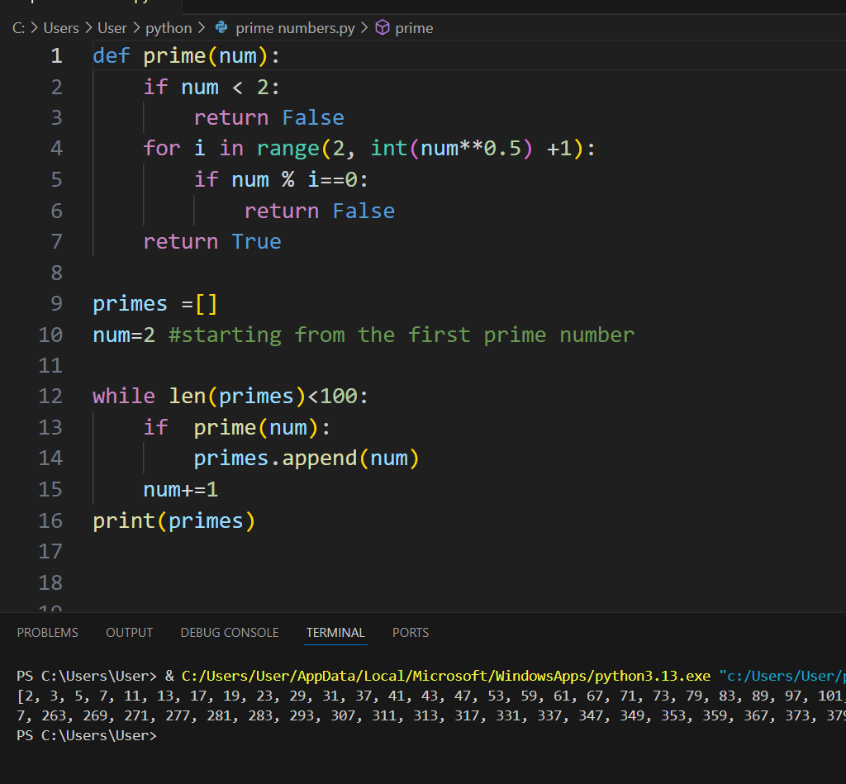

Figure 4: Loops
Week Two (23rd February - 1st March)
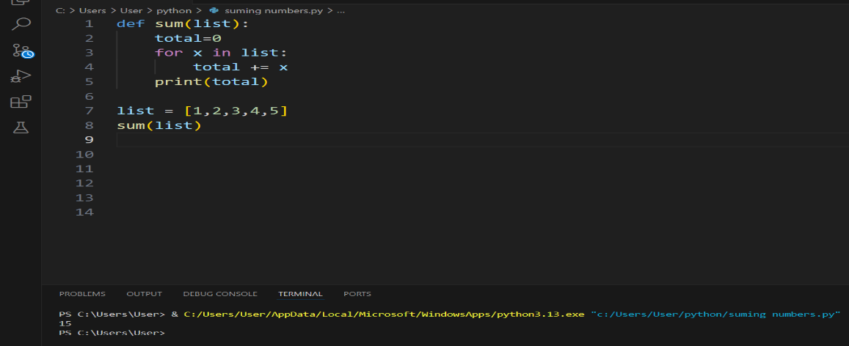
We continued with python, learning about functions( creating functions, working with functions and being able to call them if need be), classes(creating classes, adding objects under the class and being able to use it)

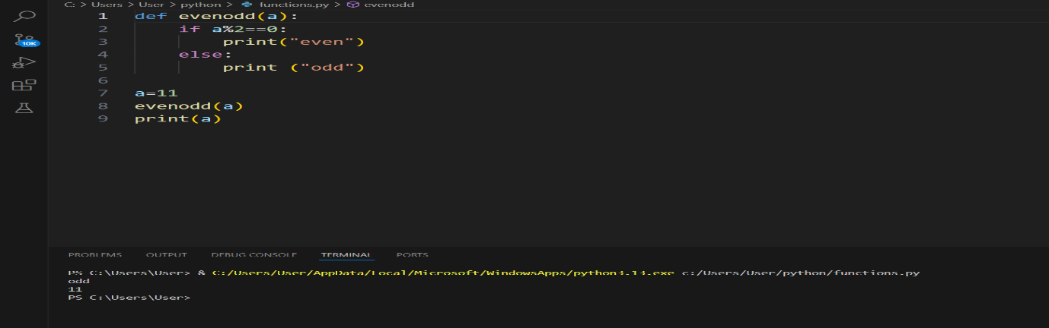
Figure 5: Functions to sum numbers

Figure 6: Function to check if a number is even or odd

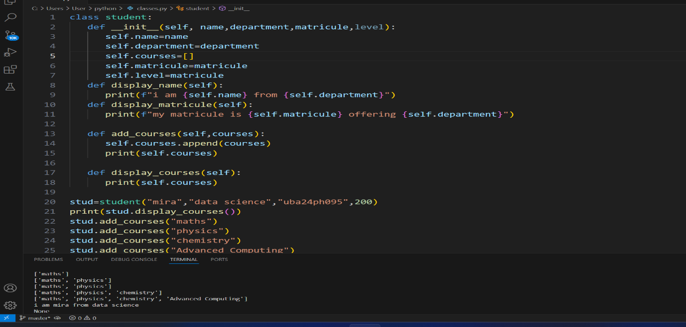

Figure 7: classes (Student class)
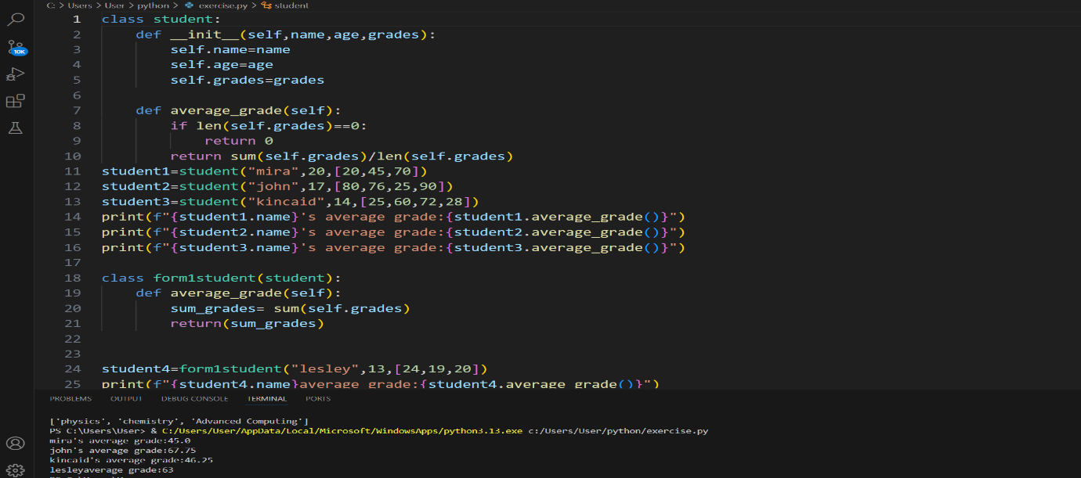

Figure 8: Exercise under class

Week Three (2nd – 8th March)
We checked validity of some formalities such as dates of births and the UBa student matricule as well as email addresses using regex function in python and we learned about Git, git hub and storing your data on Git hub by means of Git commands

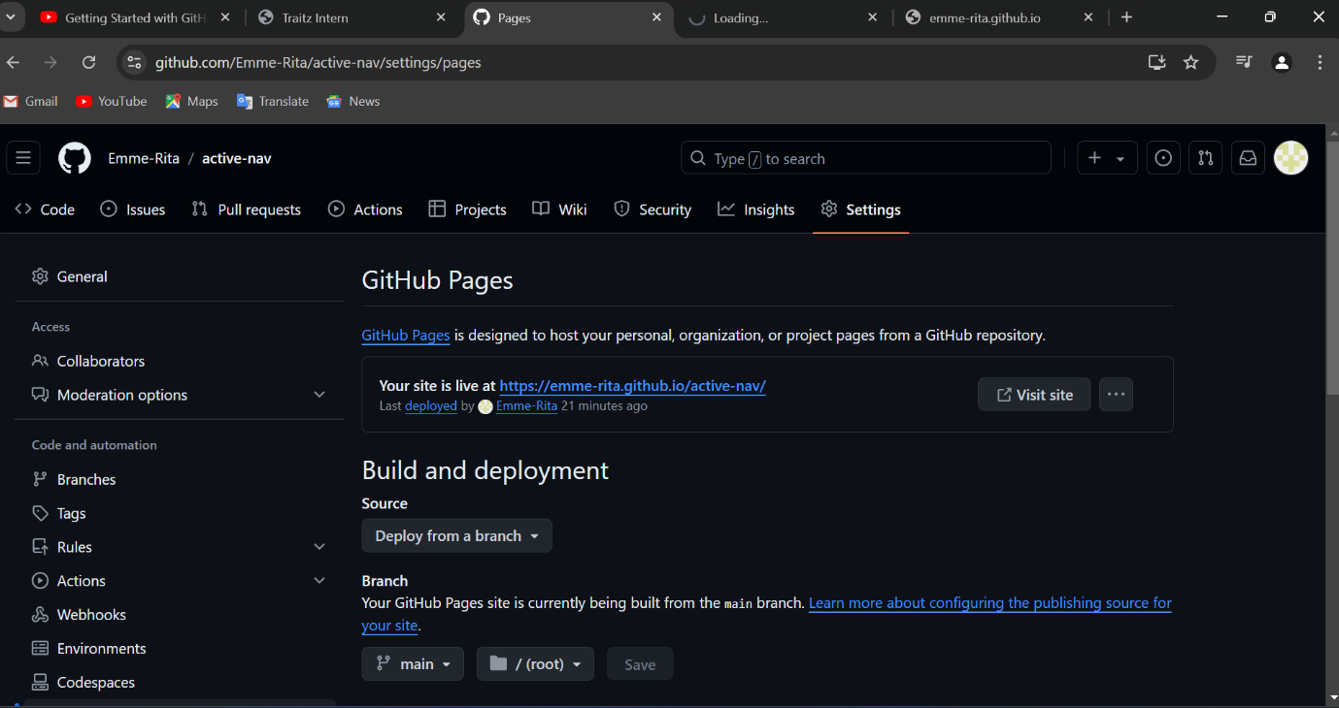

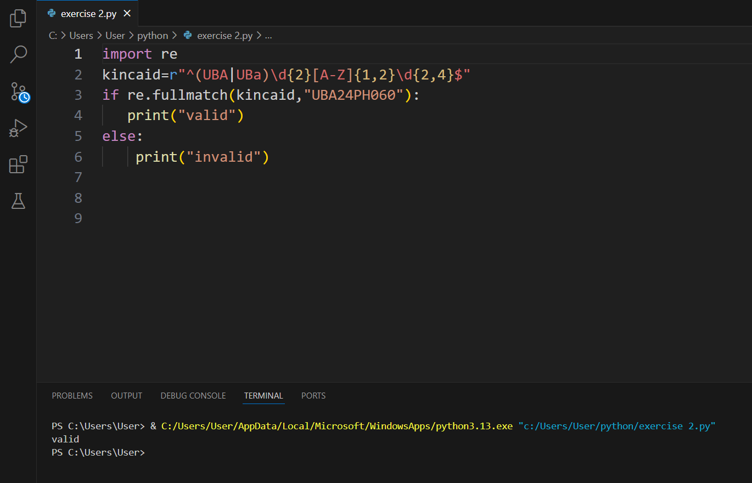
Figure 9: Git hub account

Figure 10: Regex function for checking UBa student matricule
Week Four (8th – 15th March)
We were brief on the project we were to be involved in as well as how to write and present the report on Ms power point. Here I will present the project proper starting from reading file into python and also how I was able to use the data I obtained to answer or solve real life problems

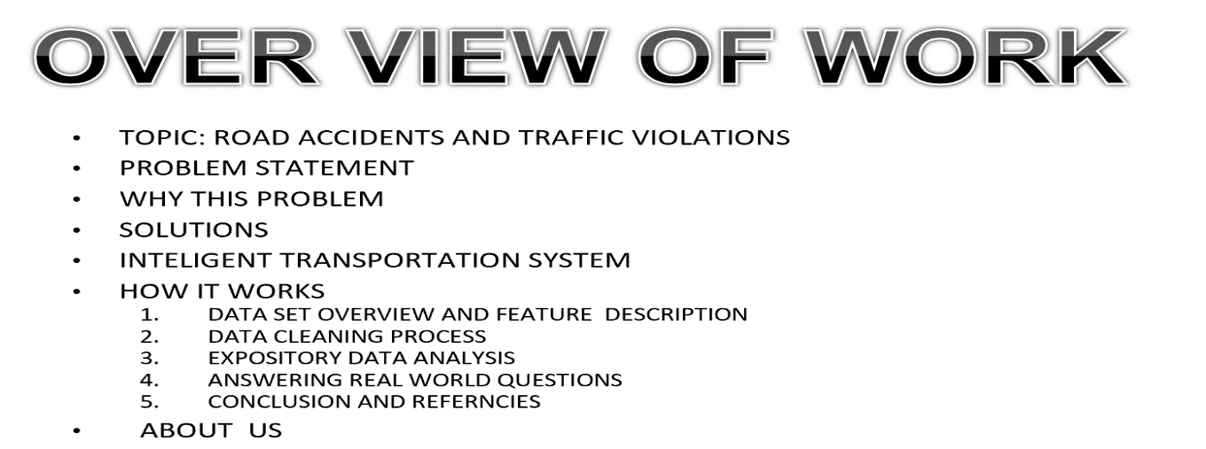
Project Proper

Figure 11: Over view of work
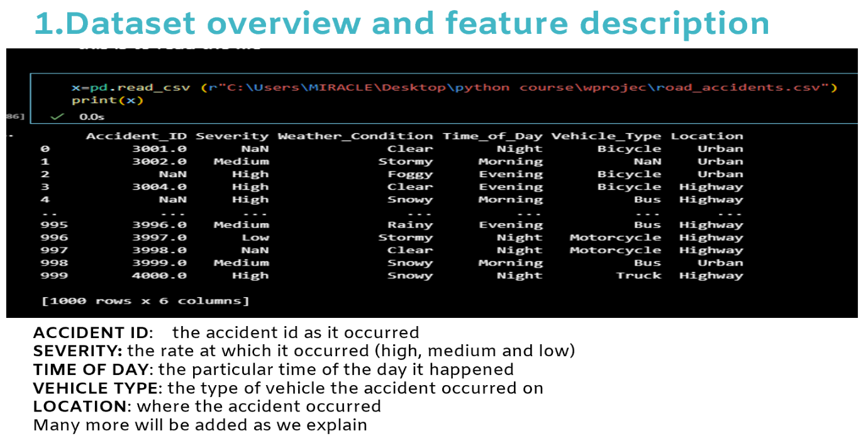

Figure 12: Dataset overview and feature description
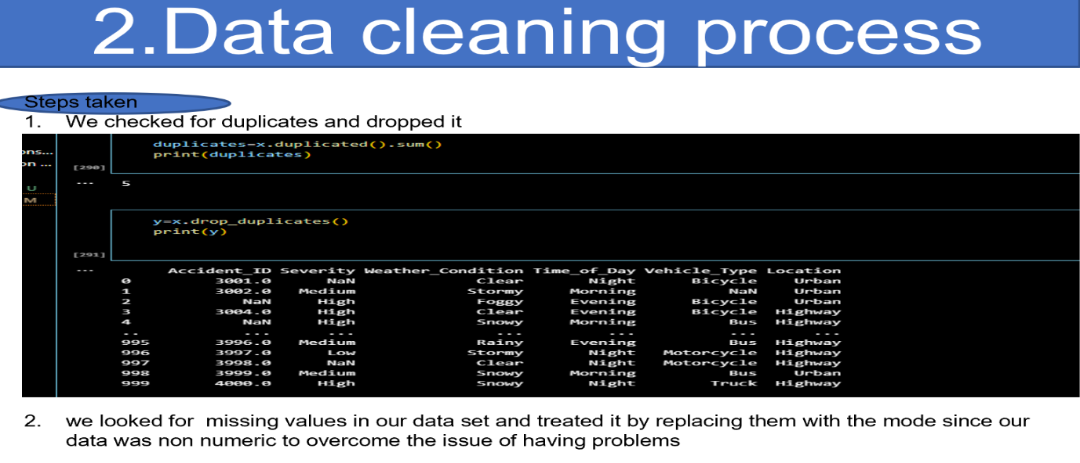

Figure 13: Data cleaning process
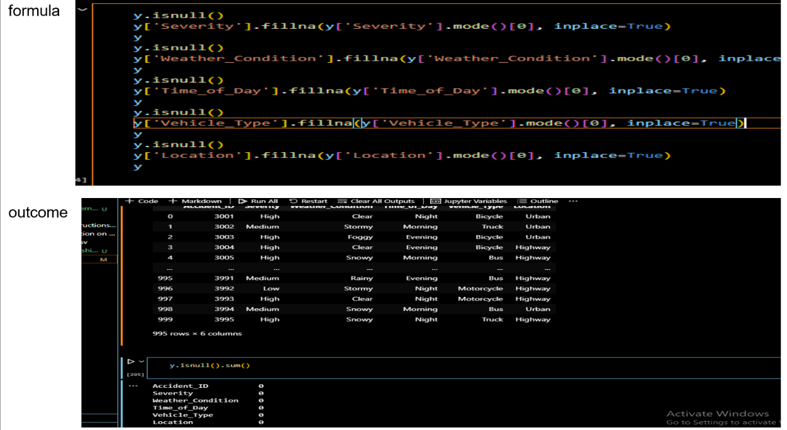

Figure 14: Formula to increment missing values with the mode
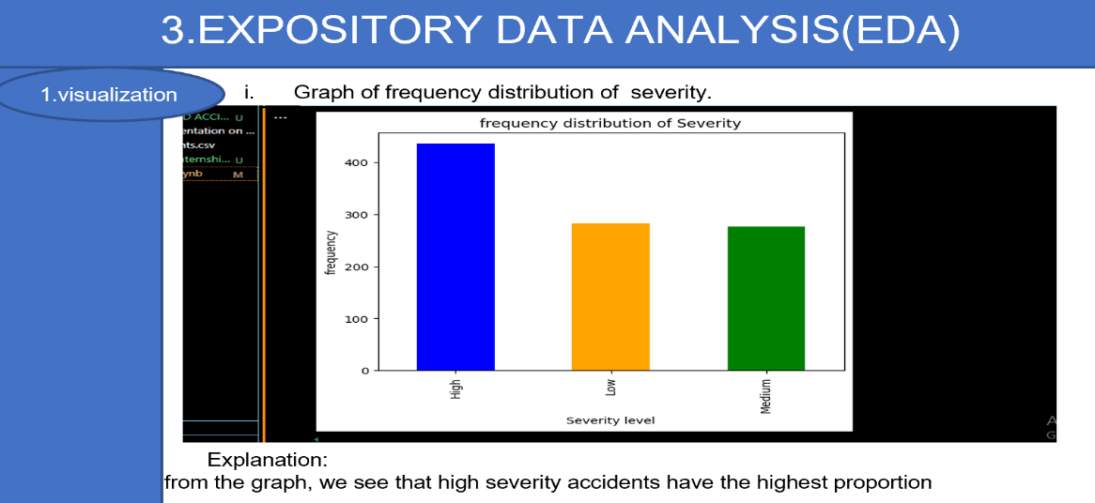
DATA VISUALIZATION

Figure 15: Graph of frequency distribution and severity
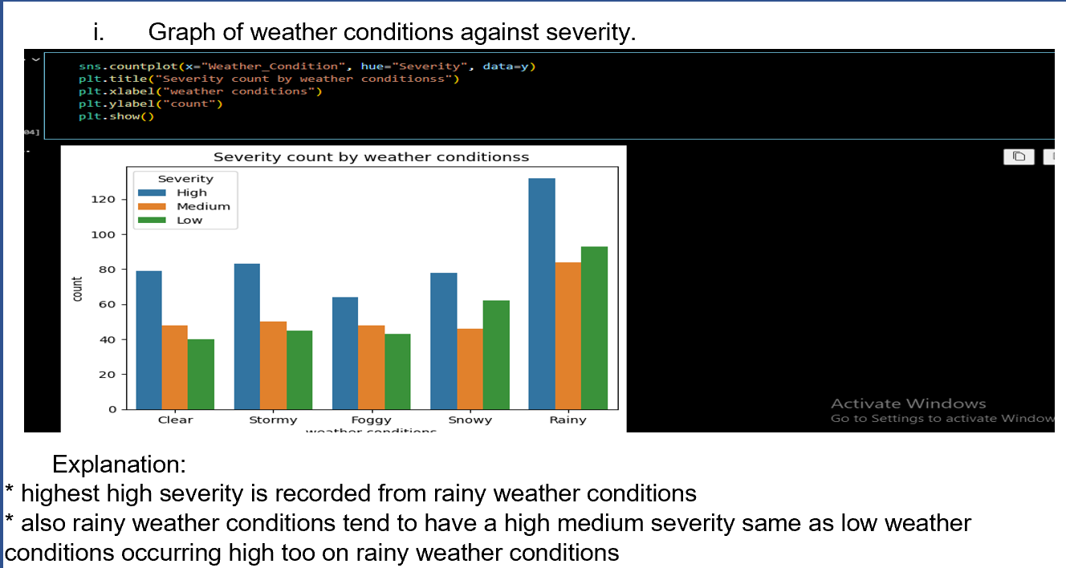

Figure 16: Graph of weather conditions against severity
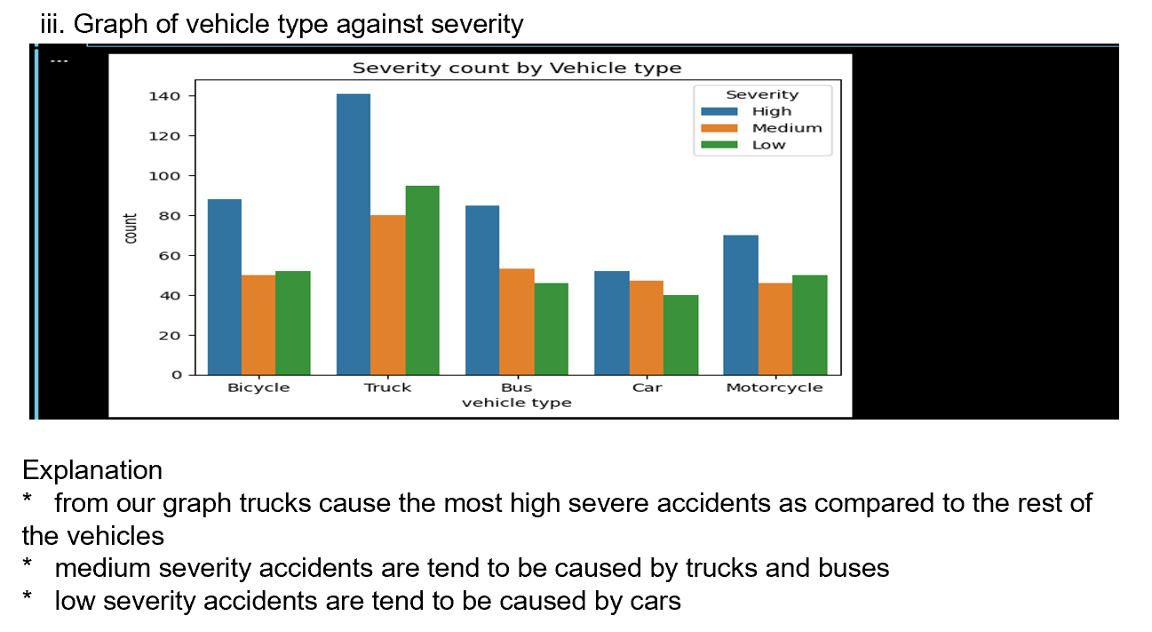

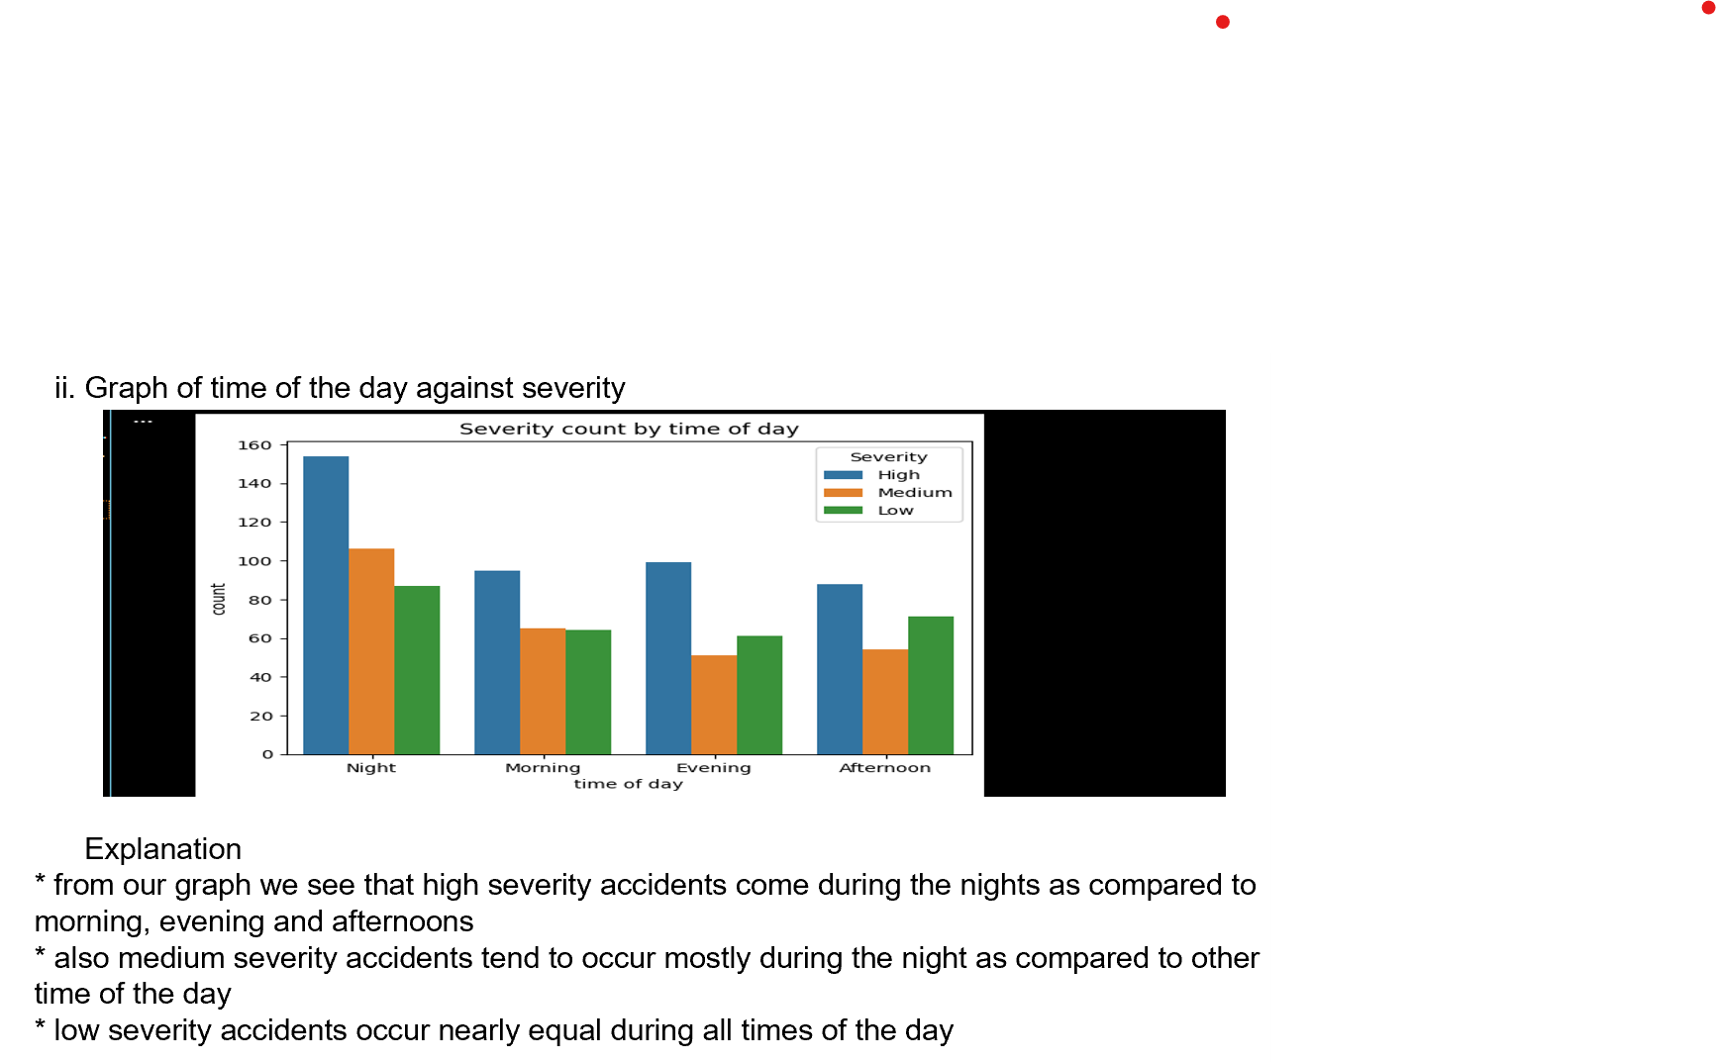
Figure 18: Graph of vehicle type against severity

Figure 19: Graph of time of day against severity
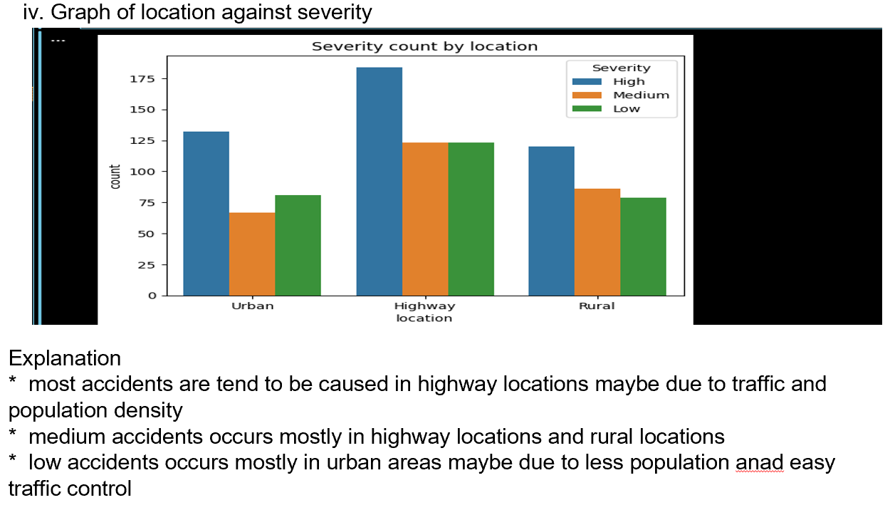

Figure 20: Graph of Location against severity

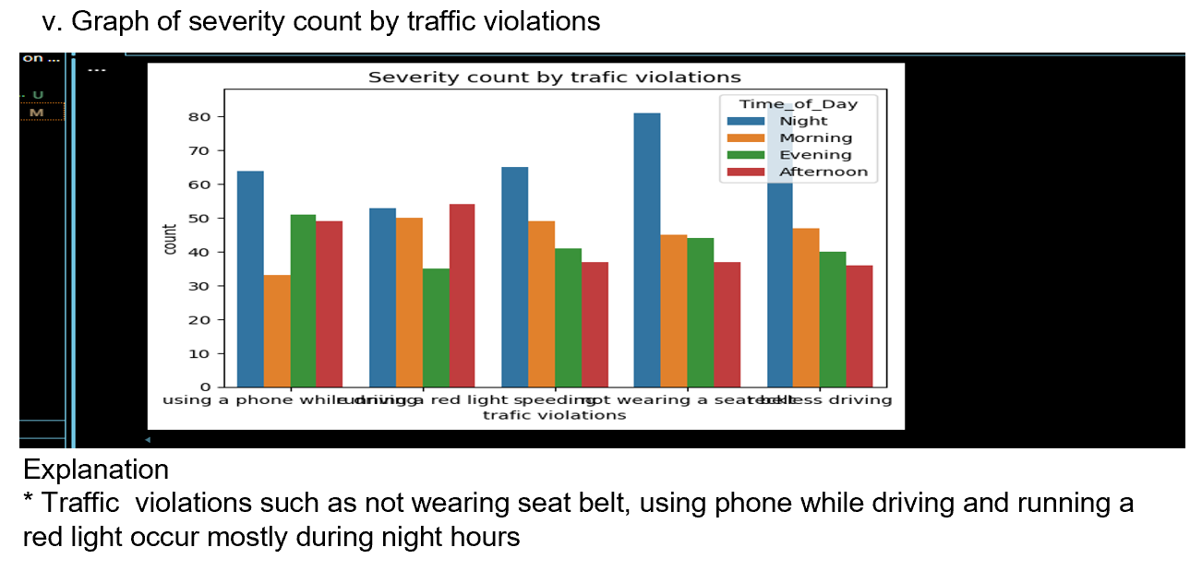

Figure 21: Graph of severity count by violations
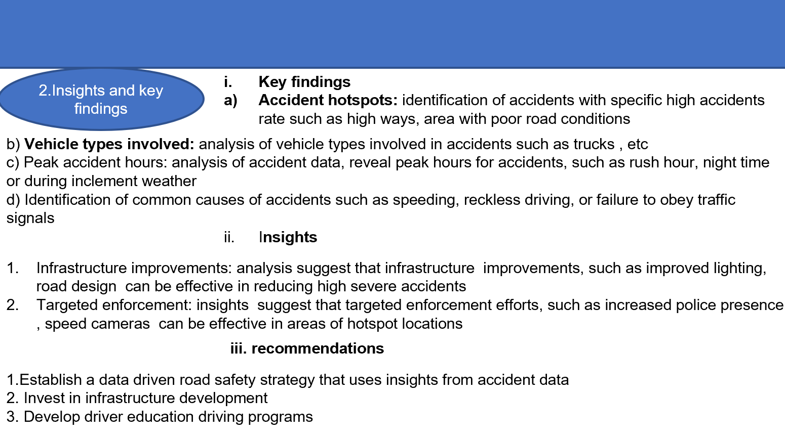

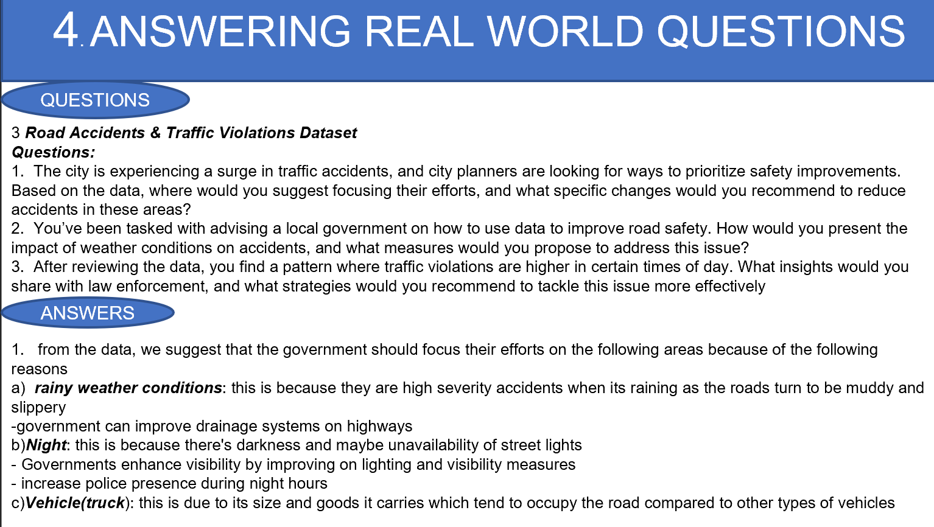
Figure 22: Insights and Key findings

Figure 23: Answering real world questions
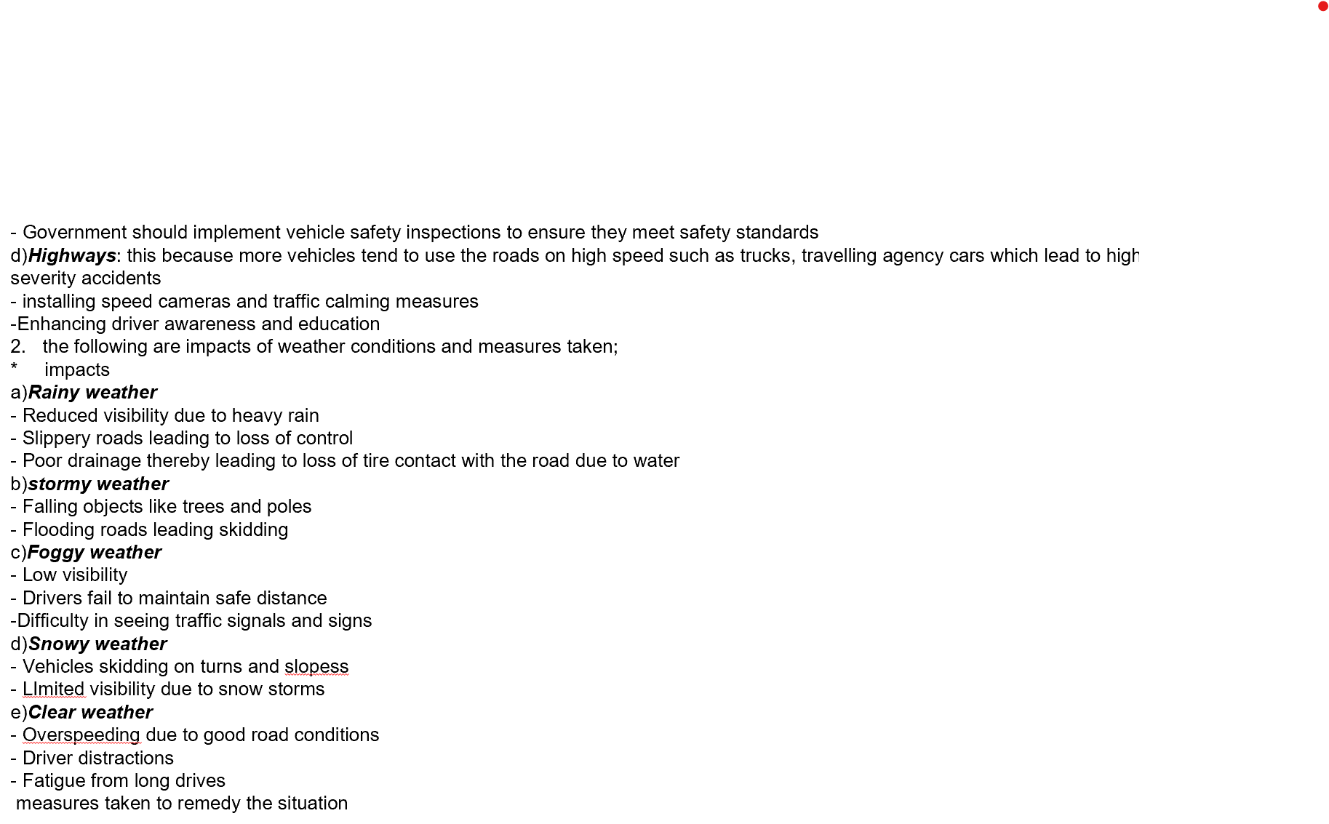

Figure 24: Answering real world questions
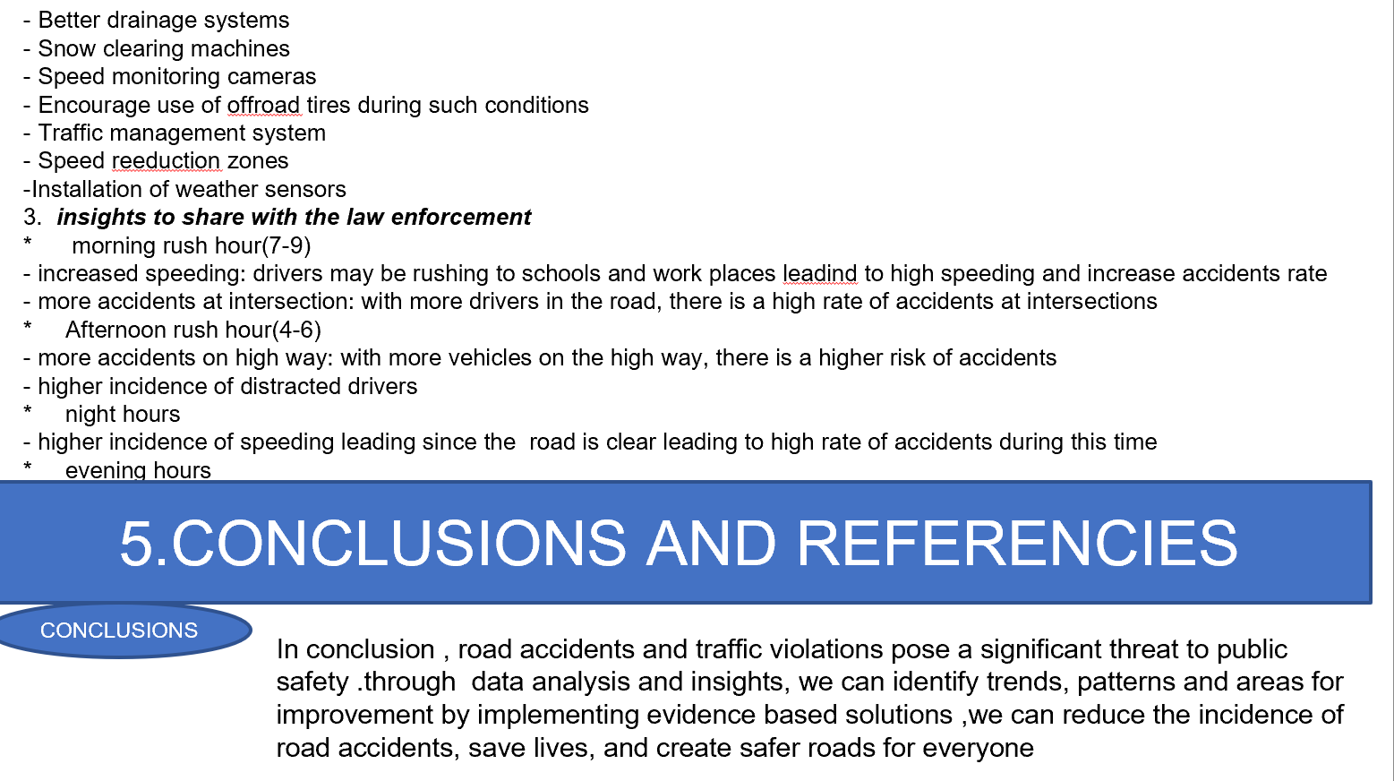

Figure 25: Conclusion
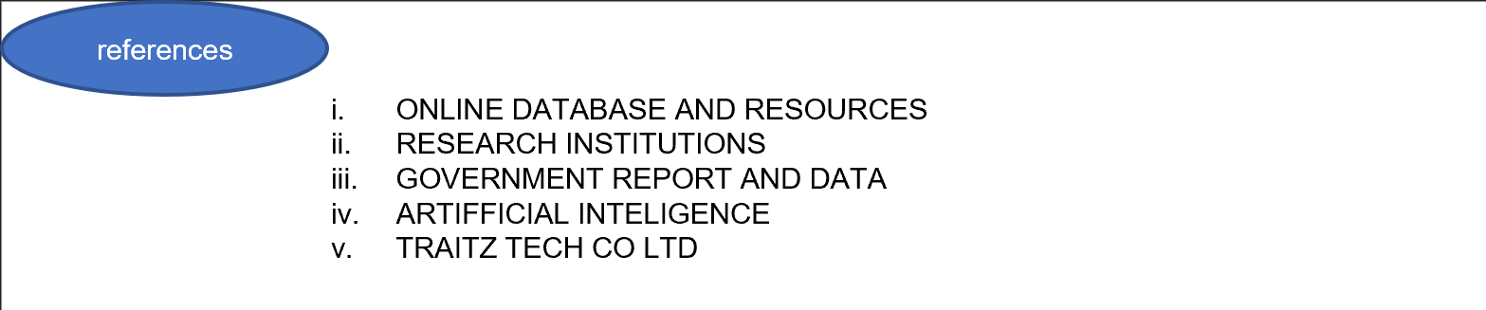

Figure 26: Reference

CONCLUSION
My internship at TRAITZ TECH was a great one because the computer engineers helped me in learning more on python coding that is, I acquired more skills in programming. I have taken my first step towards Programming with the skills acquired during my internship at TRAITZ TECH this year.
Problems encountered during execution of activities in host institution
- Electricity crisis which slowed learning
- Unstable network

REFERENCES
- ONLINE DATABASE AND RESOURCES
- RESEARCH INSTITUTIONS
- GOVERNMENT REPORT AND DATA
- TRAITZ TECH CO LTD

